## Stack of Strings

Create a class Stack which can store only strings and has the following functionality:

* Private field: **data: ArrayList<String>**
* Public method: push(String item): void
* Public method: pop(): String
* Public method: peek(): String
* Public method: isEmpty(): boolean

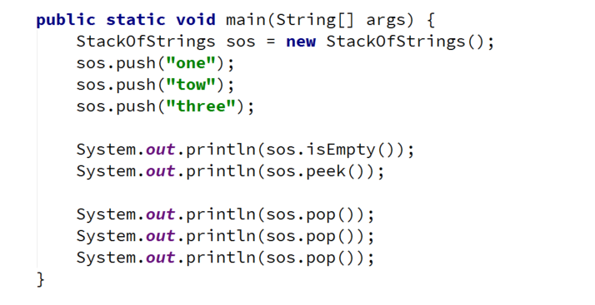

### Hints

Use composition/delegation in order to have a field in which to store the stack's data